Jedidiah Bird
Prof. Gravely
ENGL 111:08
22 February 2017
Process Analysis Essay: The T.O.R.C.H. Approach
Writing a paper can be one of the most daunting tasks for a student, but it does not have to be difficult. There is a method which I call the T.O.R.C.H. approach--Topic, Organize, Outline, Research, Rough Draft, Revise, Cite, and Hand it in--for writing essays that will help keep authors on track and ahead of their deadline. While writing a paper is a substantial task when taken as a whole, using the T.O.R.C.H. approach to break the assignment into small, manageable steps can help writers blaze through any essay.
The first thing students have to do when writing an essay is pretty self-evident; they must have a topic. While students may be assigned a topic for a lot of essays they have to write, quite often they are given the option to choose a topic. When students have a choice of topics, they should always try to choose a subject that either interests them or that they are already familiar with or knowledgeable about. Interesting subjects are ones that the student does not mind reading or writing about; while everyone has different interests, realistically a boring or tedious topic will not hold the attention of the audience, especially if the writer is not able to connect with the topic.
Once the students have a topic, they need to organize their knowledge to find out what they know (and do not know!) as well as what they want to convey. Often the topic will be fairly broad, so students will want to narrow it down into a few important parts. Students may need to do some initial research in order to understand the topic enough to pick out the important parts, but they should not get bogged down with research at this stage; they just need to know enough to build an outline at this point. They should always try to choose interrelated aspects of the topic so that their transitions are smooth and the paper does not come off as disjointed or confusing. Writers should not chase tangents; if it does not support their thesis they probably should not add it to their paper.
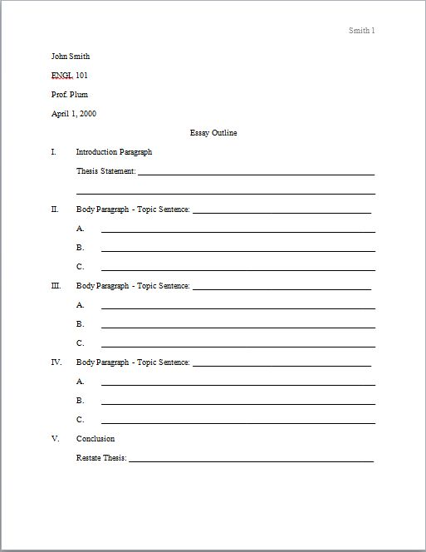
After students have their pieces organized, they should go ahead and write an outline; having an outline is generally going to help students stay on topic when they start working on their first draft. A 2014 study of high school students showed that about 56% of respondents “did not stress the importance of writing the outline as the approach in writing the essay. Consequently, they did not elaborate the main points and they only wrote whatever came across their minds without any systematic planning” (Surat pp. 215). Having an outline gives writers a reference for where each paragraph should be going, which is important as no one should want to submit a meandering, sloppy paper. Writers can always revise the outline later when they make decisions regarding draft revisions.
Figure 1 - Sample Outline
Figure 2 - Sample Outline
Once students finish their outlines, they now have some points that they need to research more thoroughly. In most cases, this will involve finding peer-reviewed academic journal articles or books on their topics. They should try to narrow their searches down to specifically the points they are trying to make. For example, if they are writing an essay on the Battle of Gettysburg they may want to research keywords or ideas such as Pickett’s Charge or the effect of the battle on the outcome of the war. They should avoid spending a lot of time on too broad of a subject; rather they should confine their research to key points they want to address in their papers.
Now that the students have some information about the subjects of their papers they should start working on their rough drafts. Rough drafts are used to put the writer’s thoughts on paper without worrying too much about the small cleanup necessary to have a final, polished draft. As a general rule, students should try to write a complete paragraph for each topic sentence they have in their outline, although there are times when they will have more than one paragraph focusing on that point. Remember to use transition sentences to flow from one paragraph to the next. As students are writing their rough drafts they should still use basic inline citation whenever they use information or quotes from another source; this will help keep their papers free of plagiarism, as well as make the process of building their works cited page easier. Completing a rough draft is one of the biggest steps in terms of visual progress for a paper; therefore, having a rough draft finished can be a great confidence booster.
After students have a rough draft they will probably have some revisions to do, as well as editing. Revising a paper is when the writer decides to add, remove, or rearrange portions of the paper to make it flow better, such as removing extraneous paragraphs that do not directly tie into the main points or rearranging paragraphs to follow a logical pattern. The first thing the writers should do is read their papers aloud. Sarah Gerwig-Moore, an Associate Professor of Law at Mercer University’s Walter F. George School of Law, in an article describing the importance of reading a document aloud in order to catch mistakes titled “Fresh Ears, Fresh Eyes: Final Editing Through Reading Aloud,” states that:
In addition to the usual pep talks, cajoling, and threats, I also recommend requiring students to read a document aloud before calling it finished. This shift from relying on one sense to engaging another helps the students stay fully connected until the assignment has been carefully inspected. Editing on a page (or worse, on a computer screen) allows a weary student to depend on unreliable electronic editing functions or skim passively and ineffectively. (972)
This is due to the fact that it is easier to catch a mistake when the author reads something aloud rather than when they are just reading it visually. When students hear a language spoken aloud they can easily pick up things like subject-verb disagreement and run-on sentences that might otherwise be skimmed over while reading, as well as whether the paper flows logically.
Another important part of the revision process is getting a second opinion. Often a teacher is willing to go over rough drafts and make suggestions; however, if they are not available or if students want to get some additional help, they can take their papers to a writing center to get help from other teachers or aides who can help guide them in the right direction. One note of caution when using outside help is that it is better for a writer to understand what changes should be made when they start to revise their paper, rather than just having someone tell them the changes that they should make. Understanding and knowing the reason for a change will help keep writers from repeating the issue later on in the revision process. Students should keep revising their papers until it sounds like something they would not mind having their names on. One way to think of it would be to think of the student’s graduation ceremony; would he be embarrassed by the commencement speaker reading his paper aloud and giving him credit?
Once students have a polished draft the penultimate, but arguably the most important, step in writing a paper is making sure that all of the quotes and information gathered from other sources are cited. The inline citations should have been done along the way, but now is a good time to make sure they were done correctly. Students should know which style their teacher expects them to deliver, such as MLA or APA, since that will determine how the citations are done. Aside from the inline citations, they must have a “Works Cited” page, or “References” list depending on the style, at the end of their paper. This is crucial to making sure they do not have issues with plagiarism or academic dishonesty. The author should make sure all sources are cited. They should also be sure to pay special attention to the punctuation usage in the “Works Cited” page; periods, quotes, commas, and italicization are important!
Finally, the last major step on the path to a better paper is to actually hand it in, and do so on time. In most cases, handing in a paper on time is better than handing it in late, even if the late paper is a more well-written one. Many teachers will take off a full letter grade every day the assignment is late, which means handing it in two days late would be a C at best, and that is in addition to the points taken off for issues within the paper. If a student isn’t going to be turning in a literally perfect paper, there is no good reason to turn it in late; the paper will most likely get a lower grade than a less polished paper turned in on time.
Now that the students have turned in their assignments they can be proud to have put in the time and effort to write an exceptional paper. They should also be confident that their hard work will be recognized. Remember, while writing a paper can be one of the most daunting tasks a student faces, the process is easy when it is broken down using the T.O.R.C.H. approach: Topic, Organize, Outline, Research, Rough Draft, Revise, Cite, and Hand it in!

Works Cited
Bird, Jedidiah. “Sample Outline.” 2017. JPG file.
Gerwig-Moore, Sarah. "Fresh Ears, Fresh Eyes: Final Editing Through Reading Aloud." Mercer Law Review, Vol. 63, Issue 3, Spring 2012, pp. 971-974.
Surat, Shahlan, et al. "The Use of Metacognitive Knowledge in Essay Writing Among High School Students." International Education Studies, Vol. 7, No. 13, January 2014, pp. 212-218.

